**Selenium webdriver** is a native browser which directly communicates with Browser.

Installation : create new project and new package, create new lib folder by right click on newly created project. Add **selenium-server-standalone-2.50.0.jar** file in to lib folder by drag and drop. Now open lib folder and select a jar file and right click to it, select option : Build path > Add to build path. It will automatically create reference libraries. This implies selenium is successfully set up.

Now create a new class and launce Firefox and load OrangeHRM website to it.

**WebDriver Driver = new FirefoxDriver(); ->** We create a Webdriver reference and assign it to an object of FirefoxDriver class.

**Webdriver is an interface**, interface in java is collection of constants and method declarations i.e. empty method.(only declaration, No code is provided for method). WebDriver methods are implemented in the Firefox class and its definition i.e the functionality of the method are written inside the Firefox class (same applies for Chrome and IE).

So WebDriver reference is created and all the WebDriver methods can be accessed.

**Consider ,**

FirefoxDriver class has extra two methods applicable only for Firefox.

ChromeDriver class has extra three methods applicable only for Chrome.

IEDriver class has extra one method applicable only for IE.

Also consider the extra methods of Firefox, Chrome and IE is not available in the WebDriver interface.

So when the above code is used we can use **only the WebDriver methods** as we have created reference of WebDriver. This is to avoid confusion for the end user thus the Object would show only the WebDriver methods which is same for Firefox, Chrome and IE.

This also proves WebDriver to be a Web Automation Framework that allows us to execute our tests in different Browsers.

FirefoxDriver driver = new FirefoxDriver(); : is also correct it will launch FF.

### WebDriver driver = new WebDriver(); : This is not correct.

Webdriver working / architecture :

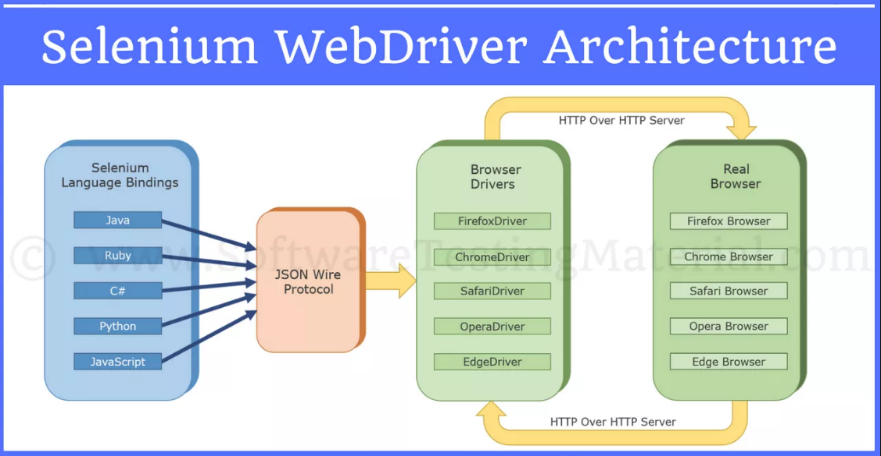we write code in respective language, every command in a code is converted into JSON wire protocol over http, i.e. every command is converted into URL. This is passed to browser driver. Browser driver provides command to actual driver and it is executed on the browser.

**Selenium Client Libraries/Language Bindings:**

Selenium supports multiple libraries such as Java, Ruby, Python, etc., Selenium Developers have developed language bindings to allow Selenium to support multiple languages.

**JSON WIRE PROTOCOL Over HTTP Client:**

JSON stands for JavaScript Object Notation. It is used to transfer data between a server and a client on the web. JSON Wire Protocol is a REST API that transfers the information between HTTP server. Each BrowserDriver (such as FirefoxDriver, ChromeDriver etc.,)  has its own HTTP server.

**Browser Drivers:**

Each browser contains separate browser driver. Browser drivers communicate with respective browser without revealing the internal logic of browser’s functionality. When a browser driver is  received any command then that command will be executed on the respective browser and the response will go back in the form of HTTP response..

**Browsers:**

Selenium supports multipe browsers such as Firefox, Chrome, IE, Safari etc.,